Patient Spotlight of the Month!
Lucy L.
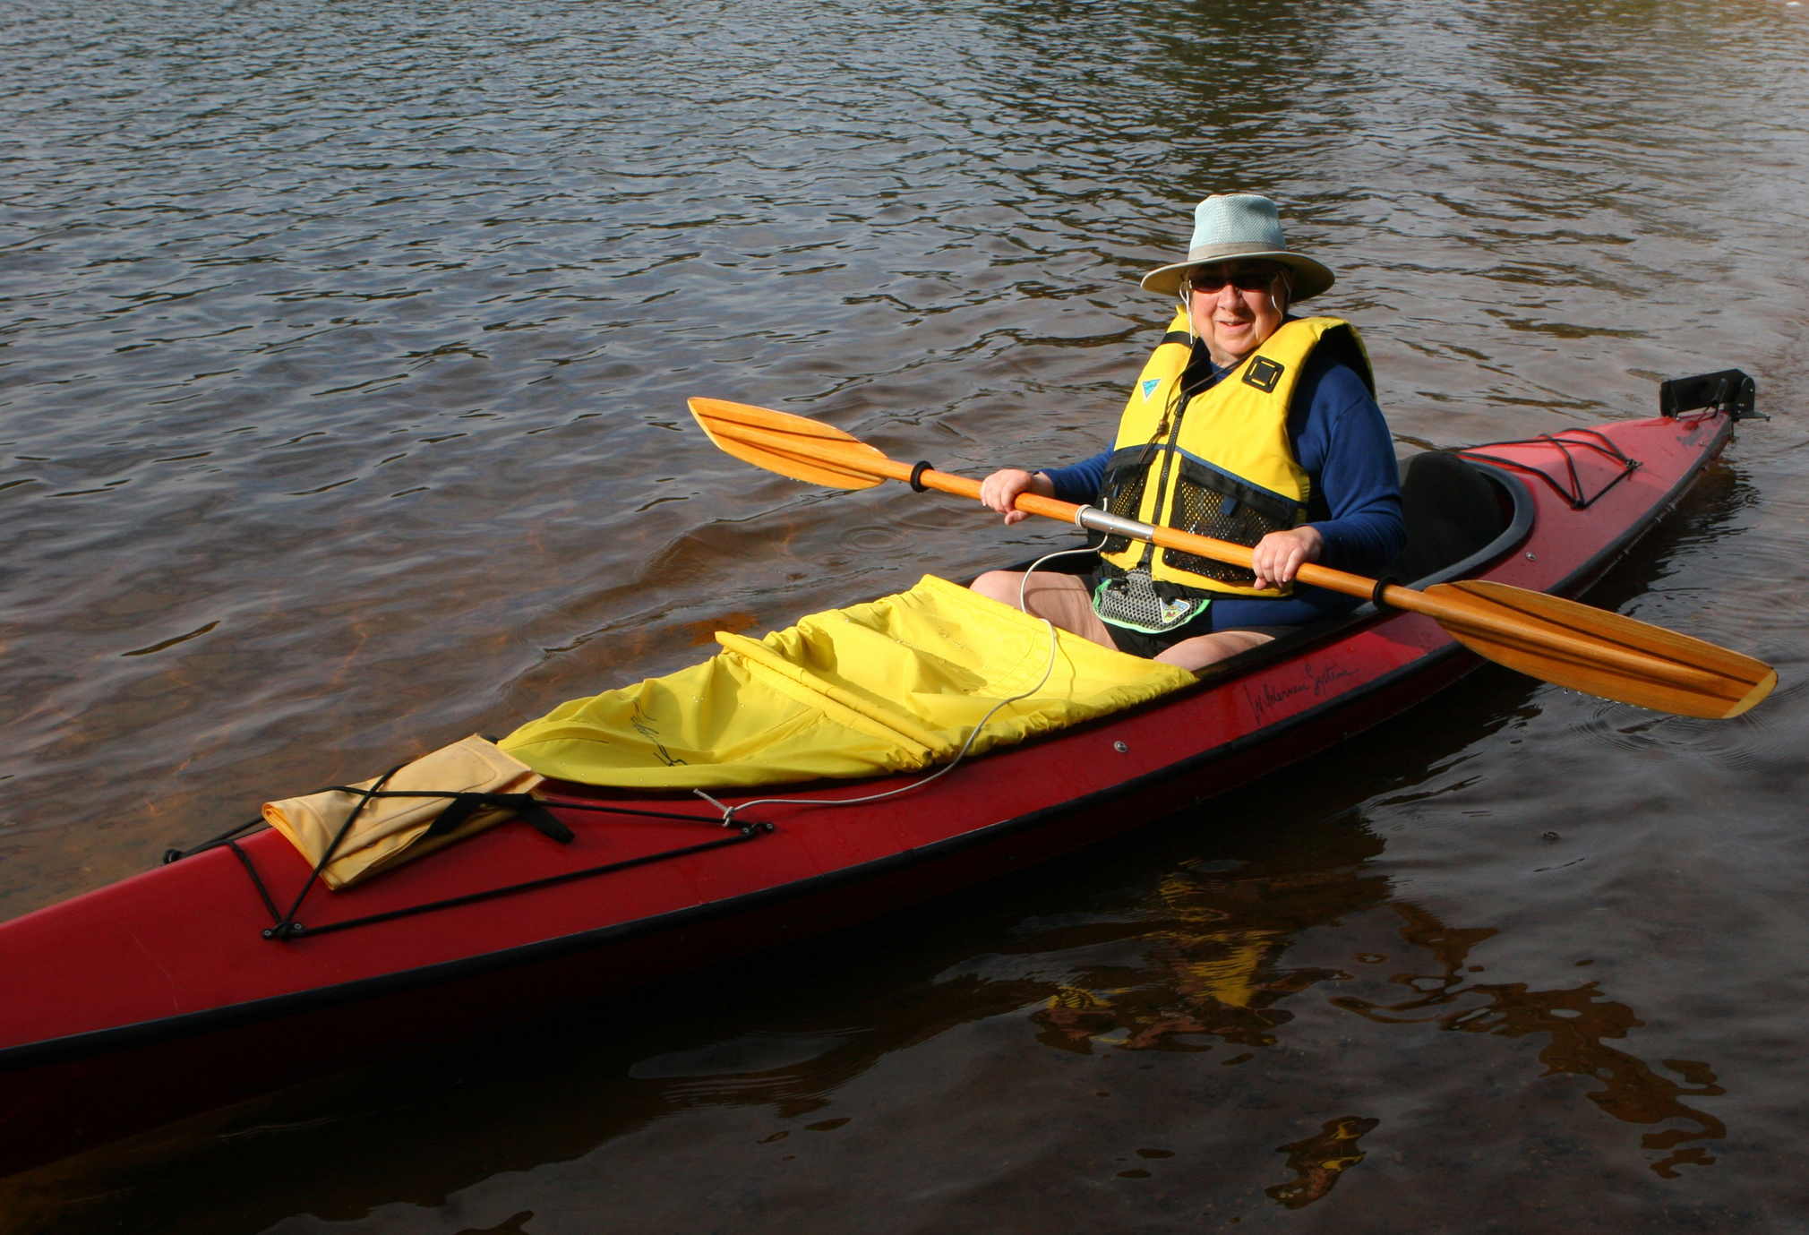

Dr. Christa Hubbard is a miracle worker and a healing angel. She makes things possible that seemed impossible. With her help and guidance, I have been able to not only walk without the aid of a cane, but to be able to do what I love to do again, go kayaking!

One thing that is so refreshing about Christa is that she listens to you and asks what your goals are. My goal has been to be able to get back in my kayak. I was off the water the whole 2017 season from a broken wrist.

Dr. Christa Hubbard also has an amazing caring team to aid in patient healing and recovery.

I worked with physical therapist Dr. Ryan Hubbard on improving the movement of my left wrist from February through April 2018 to get it ready for using a paddle to kayak. It still had not recovered to full mobility after breaking my wrist. His treatment included ultrasound therapy, manual therapy and therapeutic exercises. He even devised special exercises and tools to use that replicated the movement of paddling my kayak. The physical therapy I received from Dr. Ryan Hubbard increased the movement in my wrist so that I could safely paddle my kayak starting in May. I would not be able to kayak without his help and guidance, which I am extremely grateful for. Thank You!

Next, I injured my left knee in early May while walking down a steep hill with stiff boots on. The inside of my left knee gave way. I could hardly walk using two canes. My regular doctor diagnosed the injury as a tear in the meniscus in my left knee which was devastating because that was the diagnosis I had back in 2010 in my right knee, which laid me up for many months and continued to be a problem into 2016. Luckily, I was referred to Dr. Christa Hubbard by a friend in 2014. Christa helped with healing my right knee then, so I knew who to call when I injured my left knee.

Dr. Christa Hubbard had a different diagnosis. Instead of moving my knee to cause the pain like my regular doctor did to diagnose, Dr. Christa looked at the area closely, felt the injured and inflamed area, asked me questions about how it happened and where it hurt. She diagnosed the injury as a medial collateral ligament (MCL) sprain, a sprain of the ligament on the inside of my left knee and it was treatable. Hooray!

Kayaking was out of the question again! I couldn’t carry my boat or bend my knees low enough to get into my kayak. Dr. Christa knew my goal and scheduled appointments and therapy to help meet my goal so I could go kayaking this year.

Dr. Christa Hubbard used ultrasound therapy to help heal the sprain, electrical stimulation to strengthen the surrounding area and reduce inflammation, and manual therapy to improve my knee’s range of motion. Heat and cold therapy were also used. Dr. Hubbard had me do therapeutic exercises to regain flexibility, stability and strengthen my knee and legs. She also used neuromuscular re-education to improve my balance and coordination. She made suggestions about exercises I should do at the gym to strengthen my legs and knees, which I am continuing to do. I feel so blessed that Dr. Christa Hubbard has been able and willing to work with my injury. Thank You!

I got in my kayak for the first time in two years and went kayaking in my favorite spot! I feel so grateful to Drs. Christa and Ryan Hubbard and the whole team at Horizon Healthworks. Without them this would not have been possible. I appreciate and trust Dr. Christa Hubbard and her team at Horizon Healthworks! They work miracles!

