Patient Spotlight of the Month!
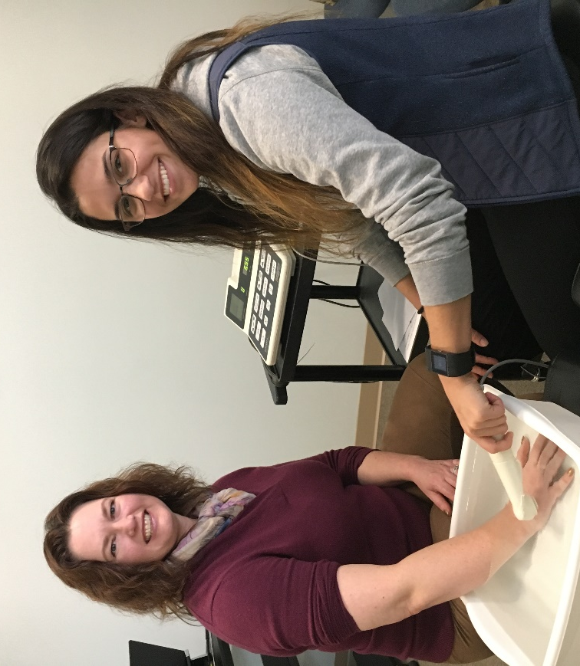
Anne D.
The level of care and personal attention I receive at Horizon Health Works is unlike anything else I've experienced in health care, either for myself or for family members. They're a remarkable team who provide superior service in every way.
I first heard about Christa Hubbard from a good friend of mine who needed help recovering from a skiing accident. In 2017 I finally had a reason to see her. After a lengthy holiday vacation, I was trying to get back into my fitness routine when I felt a strange pain in my right hip. I went to my regular doctor who prescribed an x-ray and physical therapy. At that time the x-ray showed some impingement and extra bony growths, but nothing terribly serious. I tried physical therapy for three or four months without any real progress. Then I went to see an orthopedic surgeon who took more x-rays and diagnosed arthritis. He told me I was a candidate for a hip replacement, but he prescribed a cortisone shot for pain relief first. I had that done and felt wonderful for 10 whole days! Then the pain came back and I was back at square one.
At that point I knew I needed a new approach, so I made an appointment at Horizon Health Works. My husband had been going there for a few months by then and he told me how much I would like it. He wasn't wrong! My initial appointment coincided with one of my husband's appointments, so he joined me. First, I met Dr. Hubbard and her husband Ryan, who was filling in for the wonderful PT assistant Alyssa. Then my husband and Alyssa both joined us, so it was a family affair! All 5 of us crowded into the room while Dr. Christa did a thorough assessment as well as an initial treatment which brought great relief immediately. I went home happy and excited! And I diligently did my exercises.
As the weeks went by it became clear that my pain was, indeed, caused by arthritis that needs surgical intervention. But, in the meantime, Dr. Christa and Alyssa have helped me maintain as much health as possible as well as buoying my spirits. My husband calls it the “Christa bump.” Toward the end of a treatment cycle as my pain increased my attitude and demeanor would deteriorate. But an hour with Christa and Alyssa always made me feel better and I would come home excited and easy to be around again.
And, let's not forget Katie at the front desk. It's always a pleasure to see her smiling face and to hear what she's up to. She does an outstanding job scheduling all our appointments and helping us adjust dates when needed. Everyone at Horizon Health Works does stellar work. It's such a treat to see a health professional who listens intently and cares so much about their patients. I feel lucky to live in the same town as the Hubbard family and their practice!

