Patient Spotlight of the Month!
Liz W.
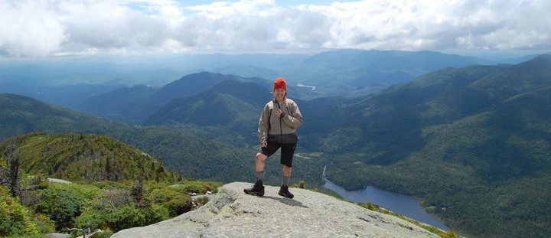

I can’t imagine my health and wellbeing without thinking of the help I’ve received from the team at Horizon Healthworks. I’ve struggled with migraines for most of my life, but after a rock climbing accident 5.5 years ago, they seemed to increase in frequency and severity. I could barely go a week without being wiped out by the crippling pressure in my cranium. I could still go to work, but it was tough - lights, sounds, and smells were all intensified and it made it nearly impossible to get anything done. I tried the “traditional” medicinal route, but all these drugs did were make me exhausted and lethargic. It was a catch 22, and just didn’t work for me. Finally, in November of 2015, a friend of mine recommended I check out Dr. Christa Hubbard. That move changed my life.
I always assumed my headaches were solely the result of a poor diet, smells, or the weather. After just a few visits, I realized that my fused ankle and gait were prime culprits in my saga. Through a variety of eye and vestibular rehab exercises, I could feel my “fatigued” left eye begin to get stronger. Dr. Christa and Alyssa also designed a walking regimen for me that helped strengthen my ankle and hip, which in turn, helped my migraines and overall health and well-being. Through small lifestyle changes and these exercises, I’ve gone from having multiple migraines a week, to maybe one or two a month.
The help I’ve received doesn’t end there. Recently, I was involved in a cross-country skiing accident. I went to the chiropractor who had no clue what was wrong but tried a few things to no avail. He sent me to my primary care doctor - she thought it was broken, but the x-rays didn’t show anything. So, she sent me to an orthopedist who didn’t make much of an effort to get me in quickly. Through all of this, via email and an office visit, Dr. Christa was my mental rock telling me that she didn’t think it was a rotator cuff tear (which the orthopedist was convinced). I then got an MRI, which, low and behold, showed a hairline fracture of my humerus. I followed up with the orthopedist - I’m not even sure he knows my name. I was in and out of his office in about 10 minutes after waiting two weeks for the appointment to read my MRI results. Luckily, I had an appointment set with Horizon HealthWorks immediately following the ortho visit. Here, I felt like a person and not a number. Dr. Christa and Alyssa spent time with me working on a precise plan to get my arm feeling better quickly. We spent over an hour working out a plan, and I actually felt cared for and like my success meant something to them.
My biggest takeaway from my time as a patient at Horizon HealthWorks is that I am a complete person, and despite being one of many, I am unique. I am important. My recovery and journey mean something to more than just me. I am always greeted warmly and made to feel important. My quality of life has improved with the decrease in my migraines. After my experience with my arm, I know that I’ll be taken care of no matter what situation I hurt myself in next!

