Patient Spotlight of the Month!
Diane K.

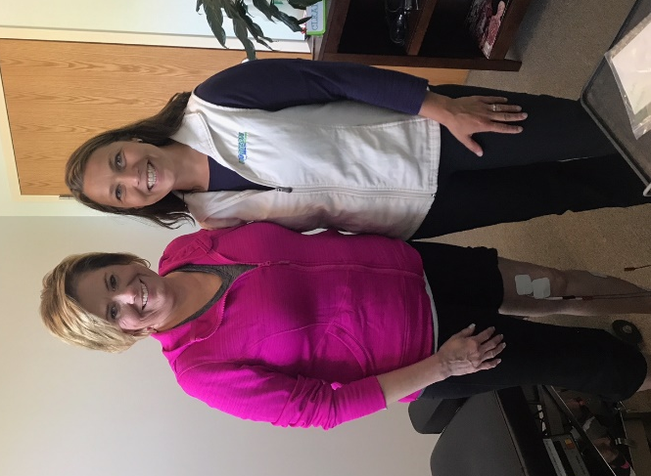

On December 2, 2016, I was skiing in Colorado at Copper Mountain and fell and broke my left leg. After having it x-rayed in the clinic at the bottom of the ski hill I was told I had a tibial plateau fracture. This meant that the tibia in my left leg was fractured right at the top of it (just below the knee) and the fracture went half way down my tibia. I had no idea what was ahead of me as far as my recovery was concerned. I was told that I needed to have surgery on my leg in Colorado, but because I did not stand on my leg after falling, the bone did not displace so I did not have to have surgical intervention. I did need to be non-weight bearing on my left leg for 8-9 weeks and I wore a brace all the time that went from the top of my thigh to just above my ankle.
I soon found out that the non-weight bearing portion of my recovery was the easy part. I started doing PT with a different physical therapy practice in town that I had worked with in the past. I made pretty good progress for the first 1.5 to 2 months. I soon saw my progress slow to a crawl and felt as though I was doing the same things each time I went and they were not making a difference. My older daughter was getting married in June 2017 so I needed to recover as quickly as I could! I was also working with Ron Berry, who is a trainer at Superior Fitness, 2x a week for an hour. I have trained with Ron for several years and have had great results with some other health issues I have had. I valued Ron’s opinion and expertise. He knew my frustration regarding my PT so he suggests that I see Dr. Ryan for PT.
I saw Dr. Ryan and was evaluated and he soon started doing manual adjustments of my knee along with e-stimulation to the muscles around the knee area. I also did a lot of stretching and strength building exercises with him. I was seeing Dr. Ryan twice a week and Dr. Christa would also evaluate me periodically. She was able to watch me walk and know which muscles needed to be worked on just from observing my gait! Dr. Christa would then also give me exercises to do at home regularly that helped the areas I was struggling in. I was amazed at how she was able to tell what I was struggling with by watching me walk and briefly talking to me and then send me home with exercises that would soon correct the problem. Dr. Ryan & Dr. Christa also send emails and texts to my trainer Ron telling him what we are working on specifically that particular week so we can also work on it in the gym. I have seen amazing results in my recovery working with Dr. Ryan and Dr. Christa. I now am getting very close to a full recovery because of their help!! I am so grateful for the care I have received at Horizon HealthWorks and so thankful I came here for help!!!

