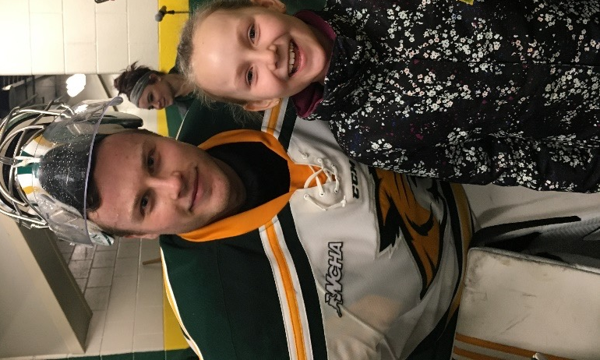
My name is Atte Tolvanen and I am a former NMU Wildcat hockey goalie. I am currently playing professionally in my home country of Finland. I was introduced to Dr. Christa and Horizon HealthWorks in November of 2017 which was my junior year at Northern Michigan University. I suffered a concussion during one of our games in Alaska. For two weeks afterwards, I was having a lot of headaches and I was unable to focus on anything for a period of time without getting headaches. I came to see Dr. Christa and after the first day of our sessions I was feeling a lot better than I had ever felt after suffering from the concussion. For the following days, I almost lived at Horizon HealthWorks and within five days of treatments with Dr. Christa I was able to skate for the first time after getting hit. A week later, I was able to return to playing in games which with that timeframe would have been impossible without the help I was able to receive from Horizon HealthWorks. I credit a lot of not missing a single game during the rest of my career at Northern for Christa's assistance. A few months ago I suffered another concussion and neck injury while I was playing in Finland. Thanks to Christa knowing how my body reacted to certain stimuli, she was able to help guide my recovery through FaceTime. With her help, I was able to return to games in a week which again wouldn’t have been possible without her help and insights into the matter.

Northern Michigan University Records

- WCHA Goaltender of the Year (2x)
- WCHA All-Academic Team (3x)
- First goaltender goal in school history
- School record for most career shutouts (13)
- All-WCHA first-team (2x)
- AHCA Krampade Scholar All-American
- Fourth-best mark in a single season in program history
- First Wildcats to be honored as league goaltender of the year since 2005
- WCHA Rookie of the Week
- NMU Newcomer of the Year Award
- WCHA Player of the Month
- First career WCHA tournament victory (2016-17)
- WCHA All-Rookie Team
- WCHA Rookie of the Month
- WCHA Scholar-Athlete
- Broke the WCHA men's record by blanking five-straight opponents from Jan. 21 to Feb. 11 (2016-2017)
- Second goaltender in NCAA men's history to surpass 300 scoreless minutes
- NCAA First Star of the Week
- WCHA Defensive Player of the Week honors

