Patient Spotlight of the Month!
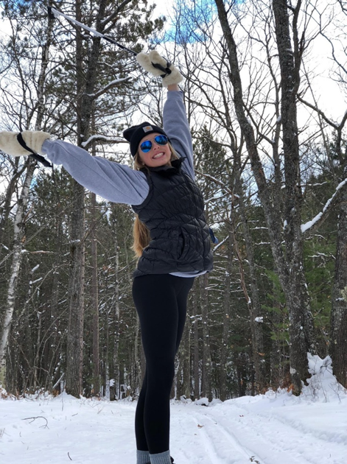
Haylee B.

Prior to coming to Horizon Healthworks, my day consisted of constant neck pain, blurred vision, and occasional headaches. It got to the point where there were multiple days I could not get myself out of bed due to the severity of pain and a nauseous feeling that was coming over me. I tried just about every pain medication out there to help diminish my symptoms as well as icing my next and forehead multiple times daily, yet nothing seemed to help my pain. After months of feeling this way, I ran into a close friend who happened to notice my pain and the symptoms I had been feeling. This wonderful friend, Alyssa Erspamer, who also happened to be a PTA alongside Dr. Crista at Horizon Healthworks, noticed I was in pain and insisted I must go in to see Dr. Crista. I soon got into Crista hoping and praying she could help my pain. All it took was one visit to finally feel like this pain may only be temporary. My family told me I was crazy, that these little exercises wouldn’t fix this enormous amount of pain I had been feeling for so long, but much to their surprise, Dr. Crista worked her magic and today I am no longer experiencing neck pain, blurred vision, or headaches what so ever. I am now able to continue my education at Grand Valley State University without the pain during studying and plan to continue my daily exercises to maintain good health. I continue to see Dr. Christa during my visits home to continue to train my eyes and shoulders to prevent future pain, and always am welcomed with such a positive team, knowing that whatever symptoms I may have, Dr. Christa is going to do everything she can to help me feel the way I should. I am so thankful for not only Dr. Crista and her amazing work, but also her wonderful assistant Alyssa, and the rest of their team here at Horizon because without them I would have thought this pain was something I would experience for the rest of my life. I now know that pain is only temporary, and that miracle workers do exist. Thank you to Dr. Christa for being mine!

